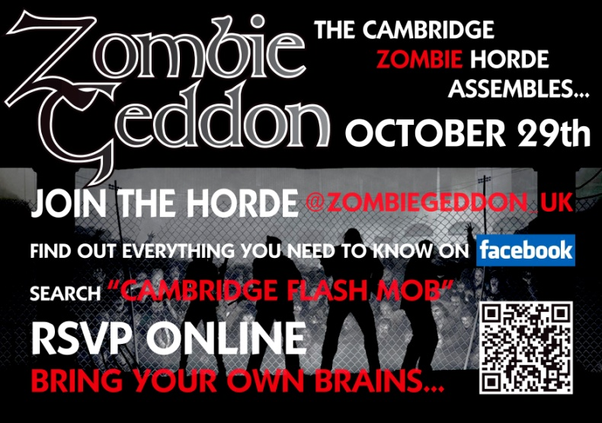
Date – 29th October 2011
Subject – Zombies Rise Up in Cambridge
Contacts – for all enquires please email Tyler-m@hotmail.co.uk

Shoppers in Cambridge will be in for a surprise on Saturday morning, as hundreds of the un-dead will take to the streets!
The group @zombiegeddon_uk have used twitter and facebook as well as other social media to contact zombies from across the uk to come to Cambridge to enjoy its history and to celebrate there Halloween in style.
“While the aim is for our zombies to have fun”- says Tyler Mortimer of zombiegeddon “we can’t ignore some of the negative stereotypes we see about zombies everyday. After all peanuts are just as dangerous but we don’t see them in blockbuster movies full of violence”
Most zombies just want to go about the un-dead lives in peace. Support groups like @zombiesunite.org and @zombierights also fight the never ending torrent of bad press the zombie community receive.
In the sprit of Halloween we invite you to come joooiiinnnn ussss!
There will be some great photo opportunities as well as a chance to get to know a zombie like never before.
You can find out more by visiting the face book group
http://www.facebook.com/event.php?eid=197207026994943
Or our twitter @zombiegeddon_uk
Photographs can be made available from the event upon request
ENDS

